Allowing others to connect to my (Netgear WGR614) wireless network

Step 1
Go to the computer you want to have access
Click Start
Click Run
Type what is between these brackets [ cmd ] and Click OK
Type this [ ipconfig /all ] and press Enter

Look below at the example
Write down the Physical Address (You may have more than one, but the only one that matters is under the Wireless section)
========================================================
Wireless Ethernet adapter Local Area Connection:

Connection-specific DNS Suffix . : aol.com
Description . . . . . . . . . . . : Linksys LNE100TX Wireless Ethernet Adapter
Physical Address. . . . . . . . . : 00-12-17-5B-BE-DD
Dhcp Enabled. . . . . . . . . . . : Yes
Autoconfiguration Enabled . . . . : Yes
IP Address. . . . . . . . . . . . : 192.168.1.101
Subnet Mask . . . . . . . . . . . : 255.255.255.0
Default Gateway . . . . . . . . . : 192.168.1.1
DHCP Server . . . . . . . . . . . : 192.168.1.1
DNS Servers . . . . . . . . . . . : 192.168.1.1
Lease Obtained. . . . . . . . . . : Monday, December 19, 2005 10:49:40 AM
Lease Expires . . . . . . . . . . : Monday, December 26, 2005 10:49:40 AM
========================================================

Step 2
Go to a computer that is already connected and working on the Internet
Click on Start
Click on Run
Type in [ iexplore 192.168.1.1 ] and click OK
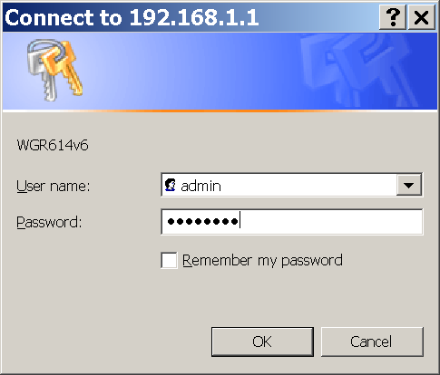
Type in [ admin ] as the User name
Type in [ xxxxxxX7 ] as the password (six small, one big, and the number seven)

On the left hand side click (Under Advanced) Wireless Settings


Click Setup Access List
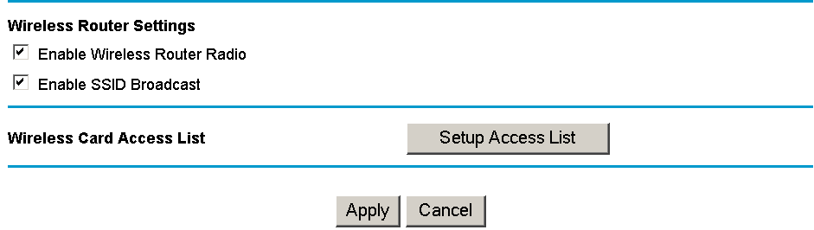

Choose Add
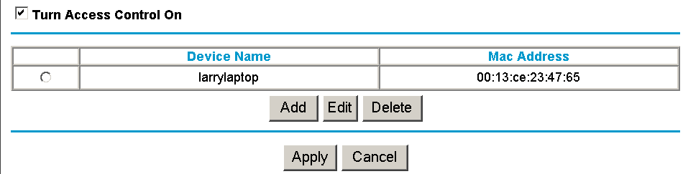

Type in a device name you would recognize (We will use larrylaptop for the example)
Type in the MAC Address you wrote down earlier but without the hyphens.
i.e. 00-13-CE-23-47-65 would be 0013ce234765.
Click Add
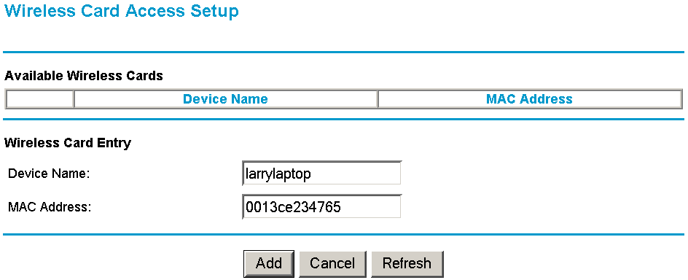

Click Apply
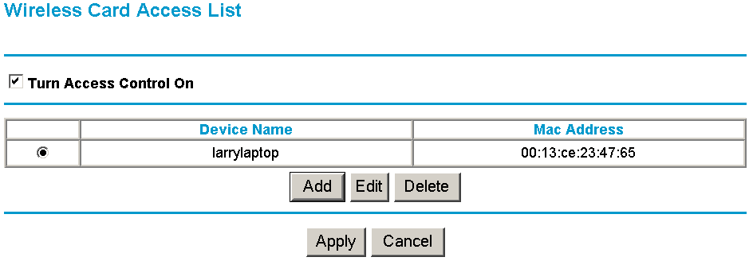
Close everything, reboot the computer that needed wireless and try to get in.

